23rd Annual Fort Frederick 18th Century Market Fair
Big Pool, MD
Thursday, April 27 – Sunday, April 30, 2017
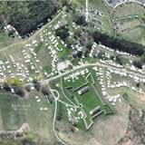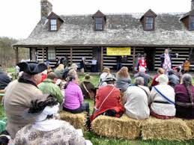
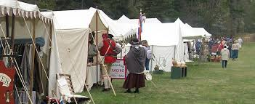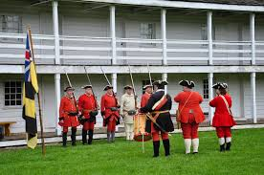
Journey to the past!

Now in its 23rd year, the Fort Frederick 18th Century Market Fair features the best period artisans, craftspeople, and sutlers together with an 18th Century encampment. Explore Maryland's French and Indian War era stone fort built in 1756. See hundreds of reenactors and 18th century sutlers (vendors) selling 18th C. period wares: paintings & prints, clothing & fabric, books, camp gear, muskets, fireplace & cooking hardware, lanterns, copperware, etc. It’s all here! Attend the Auction on Saturday for great buys on items donated by the sutlers.

Hosted by the "Friends of Fort Frederick" in partnership with the staff of Fort Frederick State Park. Directions: Take exit 12 (MD 56) off of I-70, about 15 minutes west of Hagerstown. Hours are Thursday, April 27, through Saturday, April 29 from 9 am to 5 pm and Sunday, April 30, from 9 am to 3 pm. Entrance fees are Adults - $5, Children 6 to 12 - $2, Children 5 and under – Free. 4-Day Passes are available – contact the Visitor Center at 301-842-2155.

For more information, see the Friends of Fort Frederick State Park website at www.friendsoffortfrederick.info or use your QR reader to get there…

